Local Kine Plate Lunch
Plate lunches served w/white or brown rice and tuna mac salad or tossed greens.

Country Fried Steak w/homemade chorizo gravy. 16.95
‘Ono Kalbi: boneless sterling silver short ribs marinated in our secret kalbi sauce and grilled to perfection. 19.95
Grilled Furikake Salmon with sweet ginger soy sauce.16.95
Chicken Katsu with sweet chili aioli. 13.95
Unko’s Smoke Meat smoke pork sautéed with onions and Unko’s lilikoi smoke sauce. 14.95
Hamburger Steak with grilled onions and mushrooms, topped with brown gravy. 13.95
Kalua Pig with cabbage. 14.95

Salads
Choice of dressing: Caesar*, Balsamic Vinaigrette, Pesto-buttermilk,
Creamy Toasted Sesame, or Papaya Seed. Served on the side.
Extra dressing. 0.95
Caesar
Romaine lettuce, croutons, Parmesan cheese, & lemon wedge. 10.95
House
Spring mix, clover sprouts, tomato, carrots,
cucumber, red onion, & avocado. 12.95
Greek
Spring mix, sun dried tomatoes, red onion, olives, cucumber, feta, & grilled portobello mushrooms. 14.95
Cobb
Romaine lettuce, bacon, boiled egg*, avocado, turkey, carrots,
tomato, & feta. 15.95

My Cafe Burgers
Burgers served on a brioche bun with romaine lettuce, tomato, red onion and a side of special HD sauce. Served w/shoestring fries or tossed salad.

Upgrade to truffled garlic parmesan fries. 2.00

Beyond Burger (meatless) 14.95
Ground Turkey 12.95
Classic Beef 12.95
Chicken Katsu 12.95

Add ons: Grilled mushrooms, grilled onions, sprouts, cucumbers, grilled fresh jalapenos. 1.00 each
American Swiss cheese, cheddar, jack cheese, feta. 1.00 each
Bacon, avocado, fried egg. 2.00 each

Lunch Sandwiches
Served on honey-oat bread w/clover sprouts, tomato, shredded carrots, romaine lettuce, & American swiss cheese. Comes w/tossed greens or chips and homemade salsa

Veggie w/cucumber, red onion, mix greens & your choice of
cream cheese or hummus w/balsamic dressing. 10.95
Turkey Cranberry w/homemade cranberry sauce & cream cheese. 10.95
Turkey BLT w/ papaya seed dressing. 11.50
Turkey & Avocado w/papaya seed dressing. 11.75
Grilled Portobello w/red onion & balsamic dressing. 11.95

All ingredients may not be listed on the menu.
Please inform the cashier of any known allergies when ordering.
No price reductions will be made for any ingredients taken out of any dish.

Smoothies (24 oz.)
Made with real fruits. Choice of soy or almond milk. 7.95

Lava Flow
Strawberry, banana, pineapple & coconut sorbet
Avolicious
Avocado, cinnamon, honey, & coconut sorbet
PBB&H
Peanut butter, banana, & honey
Warrior
Oatmeal, Greek yogurt, banana, cinnamon, & vanilla whey protein
Tropical
Mango, pineapple, peach, strawberry, banana, & coconut sorbet
Pick Me Up
Coffee, banana, frozen chocolate, & peanut butter
Very Berry
Mixed berries, banana, & coconut sorbet

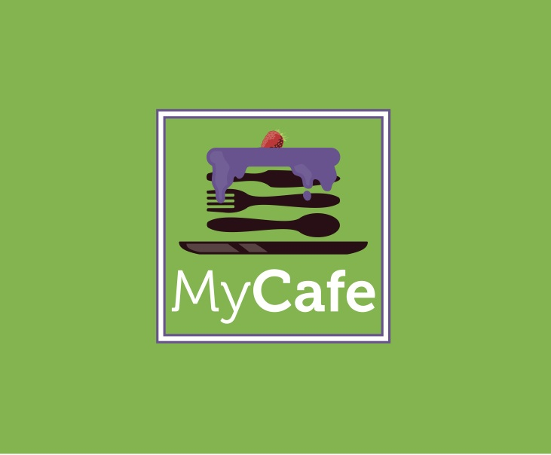

Acai Bowls
Acai blended with soymilk.

Aloha Bowl
Acai, organic granola, banana, strawberries, & honey. 10.95
Super Bowl
Acai, organic granola, banana, strawberries, blueberries,
sliced almonds, honey, & bee pollen. 11.95
Phunky Monkey
Acai, banana, chocolate chips, peanut butter, organic granola, strawberries,
& honey. 11.95
Mackey Bowl
Acai, banana, pineapple, coconut flakes, macadamia nuts, granola,
strawberries, & honey. 12.95

Extras: 1.00 each
Honey, granola, strawberries, blueberries, banana, chocolate chips,
peanut butter, sliced almonds
Scoop of Acai 2.50
Macadamia nuts. 2.00

For take-out orders please call:
808-200-5737
First Come, First Served Seating
WARNING:
We are not responsible for any cars being towed.
Please only park in Halekuai Shopping Center, anywhere else you will be towed.

