Pancakes & Waffles
All pancakes/waffles are served with whipped cream & powdered sugar

Original Buttermilk Pancakes. 8.95
Belgian Waffle. 8.95
Add: Banana, Blueberries, Strawberries, OR
Chocolate Chips. 2.00/each
Cookie Butta Luva Pancakes or Waffle
topped with a House-made Cookie butter cream sauce & cookie crumbles. 10.95
Lilikoi Pancakes or Waffle
topped with a duo of Lilikoi sauces. 10.95

My Cafe Banana Mac Nut Waffle
Belgian waffle topped with sliced bananas, homemade sea salt caramel, toasted macadamia nuts, and mac nut ice cream. 13.95

Chocolate Taro Haupia
Chocolate batter-chocolate chip pancakes, topped with a
taro-coconut sauce, & coconut flakes. 10.95
Malasada style pancakes w/ Vanilla Custard. 10.95

Flight of Pancakes
Mini Cookie Butta Luva, Lilikoi, & Chocolate Taro-haupia pancakes. 13.95

French Toast*
Served with powdered sugar and whipped cream.

Basic: Sweet bread dipped in scrambled egg, cream, sugar, cinnamon, vanilla, and nutmeg. 8.95
Loaded w/bananas, blueberries, strawberries, coconut flakes,
& Taro-haupia sauce.14.95

Extra sauce:
2 oz. 1.50
4 oz. 3.00

Scrambles
Made with 4 eggs* and come with a choice of one of the following: potatoes, white/brown rice, OR white/wheat toast.

Upgrade to truffled garlic parmesan potatoes. 2.00
Substitute egg whites. 2.00

Ultimate Veggie
Red bell peppers, tomato, spinach, mushroom, onion,
asparagus, & jack cheese. 15.95
Haillie’s
Bacon, onion, mushroom, asparagus, spinach,
sun dried tomato, & jack cheese. 15.95
Kama’aina
Bacon, ham, Portuguese sausage, spam, bean sprouts, green onions, & jack cheese. 15.95
Jalisco
Chorizo, Lomi tomato, spinach, jack cheese, & topped with sour cream, salsa, & cilantro. 15.95

Omelets*
Made with 4 eggs*, fresh grape tomatoes, grilled onion, spinach, jack cheese, and comes with a choice of one of the following: potatoes, white/brown rice, OR white/wheat toast.

Upgrade to truffled garlic parmesan potatoes. 2.00
Substitute egg whites. 2.00

Grilled Chicken & Avocado. 16.95
Chicken Apple Sausage. 14.95
Kalua Pig & Lomi tomato. 15.95

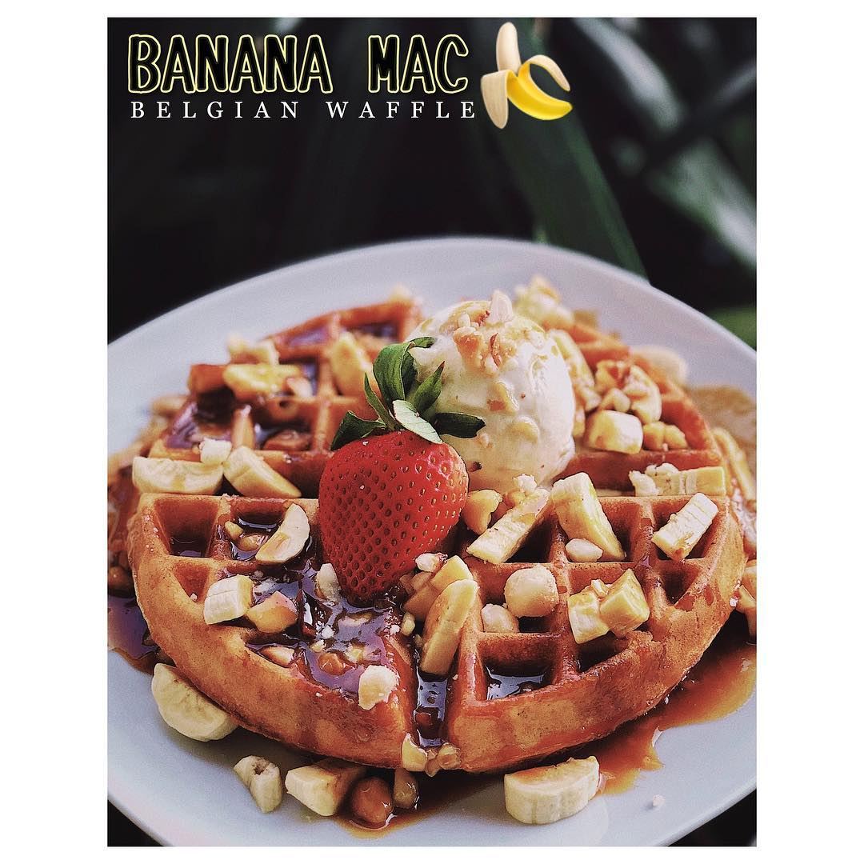

Breakfast Plates
Includes 2 eggs* any style & your choice of one of the following: potatoes, white/brown rice, OR white/wheat toast.

Upgrade to truffled garlic parmesan potatoes. 2.00
Substitute egg whites 2.00

‘Ono Kalbi: boneless sterling silver short ribs marinated in our secret kalbi sauce and grilled to perfection. 19.95
Country Fried Steak w/homemade chorizo gravy. 16.95
Grilled Furikake Salmon w/sweet ginger soy.16.95
Furikake Panko Crusted Spam.11.95
Bacon or Turkey Bacon.11.95
Portuguese Sausage w/grilled onions.11.95
Chorizo Sausage topped w/grilled onions,
sour cream, & cilantro.11.95
Pastele Sausage topped w/ sour cream, olives & cilantro.11.95
Chicken Apple Sausage w/grilled onions. 11.95
Garlic Kalua Pig Hash.14.95
Corned Beef Brisket Hash. 15.95
Biscuits & Homemade Chorizo Gravy. 15.95

Unko’s Smoke Meat
Local kine smoke pork sautéed with onions and Unko’s lilikoi smoke sauce. 14.95

Keiki Plate
Two mini pancakes, two eggs, & two strips of bacon. 9.95

Bagels
Choice of: plain, everything, taro, Hawaiian (pineapple-coconut) or jalapeno flavor.

Toasted w/Cream Cheese. 4.95
Breakfast Bagel Sandwich w/ tomato, spinach, egg*,
basil mayo, & jack cheese. 7.95
Add: bacon, turkey bacon, ham, spam,
turkey, OR Portuguese sausage. 2.00
Lox Bagel
Cured smoked salmon*, cream cheese, red onion, tomato,
clover sprouts, capers & lemon wedges.13.95
Benediction*
Eggs benedict on toasted sourdough baguette, topped w/homemade hollandaise sauce*, & served
w/breakfast potatoes.

Upgrade to truffled garlic parmesan potatoes. 2.00

Blue Crab* & Asparagus.18.95
Lox* Cured smoked salmon, cream cheese, & capers. 17.95
Kalua Pig Shredded smoked pork w/ lomi tomato. 16.95
Traditional w/ grilled ham.14.95
Veggie w/fresh tomato, spinach, mushrooms,
& Parmesan crisp. 15.95

The B.E.A.S.T.
Bacon, Eggs, Avocado, Spinach, and Tomato smothered in hollandaise.18.95

Extra hollandaise:
2 oz. 1.50
4 oz. 3.00

Loco Moco

Homemade ground beef* or turkey patty* or chicken katsu on white or brown rice; topped w/mushrooms, onions, gravy, & two eggs your way. 13.95

Substitute Veggie or Kama’aina Fried Rice. 4.00
Extra gravy. 2.50
Add tuna mac salad. 1.95

Fried Rice
(Topped w/two eggs any style*)
Kama’aina
Bacon, spam, Portuguese sausage, ham,
garlic, beansprouts, & onion. 13.95
Kuilei Veggie
Mushrooms, bell peppers, corn, spinach, edamame, garlic,
tofu, asparagus, & onion. 13.95

Latin Inspired
Breakfast Burritos
Scrambled eggs* with: potatoes, chorizo, cilantro, lomi tomato, & cheese. Served with homemade salsa & sour cream. 10.95

Chilaquiles
Tortilla chips scrambled with eggs*, homemade salsa, tomatoes and onions. Topped with jack cheese, sour cream, avocado, cilantro, grape tomatoes and fresh jalapenos. 14.95
Add Kalua Pig, or Chorizo. 3.00

Extra homemade salsa:
2 oz. 1.50
4 oz. 3.00

Light Breakfast
PB, banana, & honey on toast. 5.95
Old Fashioned Oatmeal. 5.95
Add Fresh Fruits. 3.00
Fresh Fruit Bowl. 6.95
Greek yogurt w/granola, fruit & honey. 9.95

Beverages

Self-serve water infused w/pineapple. Free
Assorted Canned Soft Drinks. 1.50
Bottled Water. 1.50
Arizona Green Tea. 2.50
Assorted Hot Tea. 2.95
Bottomless ‘Aikane 100% Ka’u Coffee. 4.95
Bottomless Coffee of the Day. 3.95
Govinda’s Fresh Pineapple Juice. 4.95
Govinda’s Fresh Guava Nectar. 4.95
Govinda’s Fresh Orange Juice. 5.45
Organic Chocolate Milk Box. 2.25

Sides
Kalbi. 13.95
Smoke Meat. 8.50
Country Fried Steak. 9.50
Biscuits and Chorizo Gravy. 8.50
Corned Beef Hash. 9.50
Garlic Kalua Pig Hash. 8.50
Portuguese, Chicken Apple, Pastele, or Chorizo Sausage. 6.25
Bacon or Turkey Bacon. 6.25
White or Wheat Toast. 2.95
Potatoes. 4.95
Truffled Garlic Parmesan Potatoes. 6.95
Tuna Mac Salad. 3.50
Furikake Panko Crusted Spam. 6.25
Avocado. 3.50
Scoop White or Brown Rice. 1.95
Egg. 2.25 each

Additional sides available, check with cashier

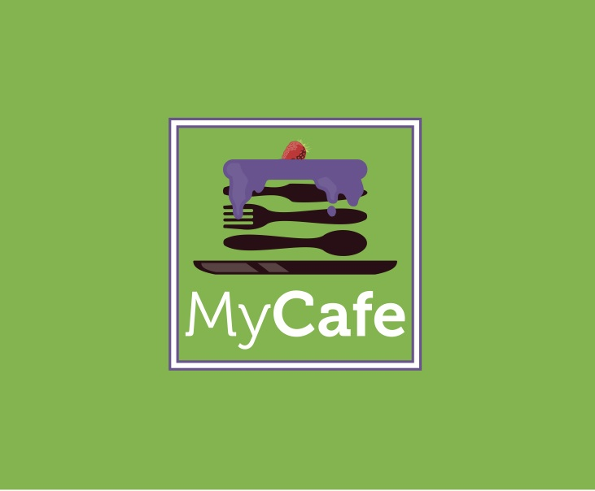
All ingredients may not be listed on the menu.
Please inform the cashier of any known allergies when ordering.
No price reductions will be made for any ingredients taken out of any dish.

WARNING:
We are not responsible for any cars being towed.
Please only park in Halekuai Shopping Center, anywhere else you will be towed.

